HOLY CROSS PARISH
505 26th Street West
Palmetto, FL 34221-5425
Phone (941) 729-3891 * Fax (941) 721-9402

GARDEN OF PEACE
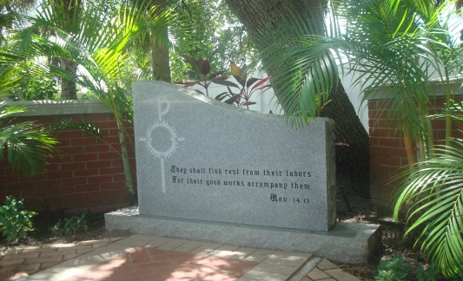
Memorial Stone Donated by the Knights of Columbus, Council #7414
Burial Planning Guide
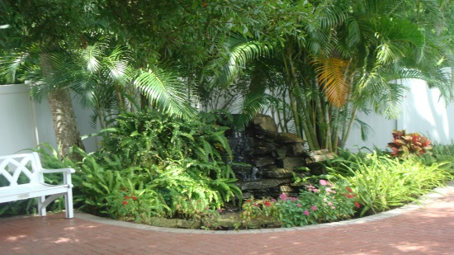

Memorial Garden Waterfall

The Holy Cross Garden of Peace is located on the Southwest corner of the Church. It is a final resting place for all parishioners and
their spouses who wish to have their cremains buried in the confines of the sacred Church grounds

The Dedication, Blessing ad Invocation
was held on All Saints Day,
Tuesday, November 1, 2005.
Making Funeral Arrangements

Before proceeding, be sure to determine if the deceased set forth specific instructions in a pre-arranged funeral plan or will.

Types of Funeral Services

Traditional Funeral Mass

The Funeral Mass typically includes:
- One or more “visitations” where the mourners gather, with the body present in an open or closed casket, to express condolences at the funeral home.
- A Mass to commemorate the life of the deceased with the body present in a closed casket. If cremated, the cremains are present.
- A procession to the cemetery where additional ceremonies may take place and the deceased is buried.

Memorial Mass

- A Memorial Mass commemorates the life of the deceased without the body or cremains present. They are usually following burial or cremation, or if the body has not been recovered (e.g., lost at sea).

Combined Traditional and Memorial Masses

- Both types of Masses – a visitation and a service with the body present, as well as one or more memorial services without the body present – can be arranged to commemorate one life. For example, a memorial Mass can be held for mourners living in other cities or to honor a public figure for whom a private service was held.
Funeral and Graveside Services
- Sometimes commemorative services are held at the
cemetery, either in a chapel or beside the grave, immediately prior to burial.

Non-commemorative Funerals
- Also known as “direct” dispositions, non-commemorative funerals are when the deceased is buried, cremated, or donated to medical science without any formal service to remember the life that has passed. (Not Recommended by the Catholic Church.)

Interment Arrangements – Final Resting Place
Your Options for Human Remains

Whether the deceased’s body is buried or cremated, a decision needs to be made about the permanent arrangements for the body. This is commonly referred to as choosing a “final resting place.”

Cremation does not preclude having a traditional funeral or Memorial Mass. It is merely an alternative method of disposition of the body. Many experts advise that cremation should not be selected as a means of circumventing or hastening the grieving process. Some people choose cremation as a means of reducing funeral costs, in particular, the embalming, casket and cemetery costs and that his acceptable.

Choosing Cremation and Burial in the
Holy Cross Garden of Peace
- Arrangements cannot be made in advance. Arrangement should be made with the Executor/Executrix of the estate. (Those who will carry out the wishes of the deceased).
- The Holy Cross Garden of Peace is a communal burial garden. No urns or plaques are permitted.
- The deceased must be a Christian. (Example: husband is Catholic/wife is Methodist)
- The first call results in an initial transfer of the deceased from the place of death to a funeral home or crematory.
- You or the funeral home director will call Holy Cross Parish to request a date and time for the Funeral Mass, Memorial Mass, Funeral Service or Graveside Service.
- A Holy Cross Parish Bereavement Planner can help you and your family cope with the loss of your loved one and with the planning of the Liturgy and music selections for the Mass.
- A Cremation Certificate from the crematory and an Application for Burial Transit Permit is requested documentation prior to burial in the Holy Cross Garden of Peace.
- The cost of the Mass and burial are contingent upon census membership and are payable prior to burial.
- The names of all those buried in the Holy Cross Garden of Peace are recorded in the burial register as required by the Diocese of Venice in Florida. In addition, each name is listed in a separate book in honor of all the deceased.
- Visitors are welcome to visit Holy Cross Garden of Peace during regular office hours or by calling in advance so that we may have the gates open.

“They shall find rest from their labors for their good works accompany them” Rev. 14:13

